**“THE LAST TREE” DEVELOPMENT DOCUMENT**

Main graphic reference : **Alto’s Adventures** <https://www.youtube.com/watch?time_continue=36&v=Wk5JupHelAg>

<http://www.altosodyssey.com/>

<https://www.youtube.com/watch?v=PaZsrAi6iJg>

<http://www.altosadventure.com/>

<https://play.google.com/store/apps/details?id=com.noodlecake.altosadventure&hl=en_US>

Main dynamics of game reference : **Geometry Dash**

<https://www.youtube.com/watch?v=k90y6PIzIaE>

<https://play.google.com/store/apps/details?id=com.robtopx.geometryjump&hl=en_US>

**LOADING STRUCTURE**

While the application is loading first of all there will be a page where is written the name of our company (Greengame), we will provide you the logo image. Under our logo will be written a curiosity that is taken randomly from a list that we will provide to you. The background during this page is white. After the loading of the company is done, there will be a second logo, it’s the game’s logo , that is gonna stay on for a few seconds. We hope that you can provide us one, the name is “The last tree” , and as image there will be a vase with a little green plant in it. After that the player jumps in the homepage.

ababa.png This is our logo to put in the first loading.

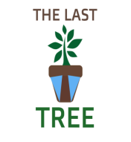This is our game logo , you will need to redesign it without the light blue parts.

**HOMEPAGE STRUCTURE**

As background we would like an image that look like this. The earth has to look like dirty and dry. The space has to look spotless and full of shining stars.

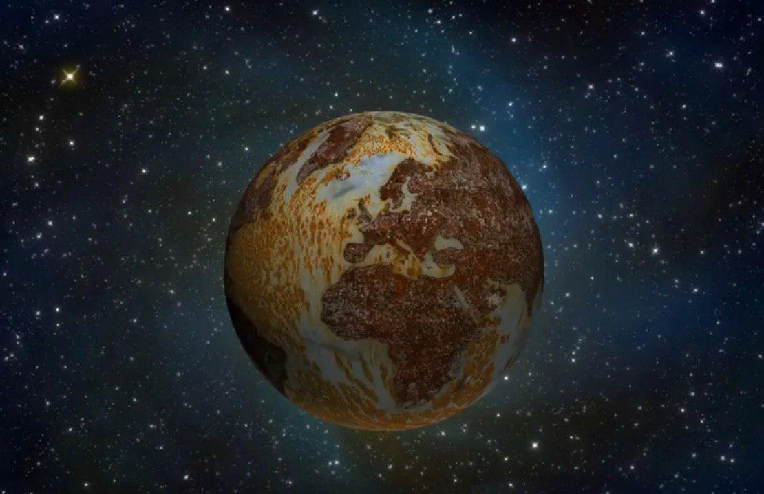

We need something like this but with a graphic that looks like more the graphic of the game that we gave you as reference. In the homepage there are five bottons. On the four corners there are settings, shop, personal profile and rankings. In the centre there is the botton start. On the top in the middle and at the bottom in the middle we need the possibility to show a little banner-type like counter with some statistics provided from us in the future.

**START**

**MAIN CHARACTER**

It is the character that run for the whole game. You can only slide or jump with him. He brings with him a vase this a plant in it, he has to save it and plant it. He is followed by a monter of oil for the whole game until last level when he disappear if he did not killed you.He is not visible on the screen, if you are slowed down one time by the objects , he appears in the screen, if you are slowed twice in a row you get killed by him. Graphically the main character can be like this with a vase-plant in his hands (the logo one’s) :

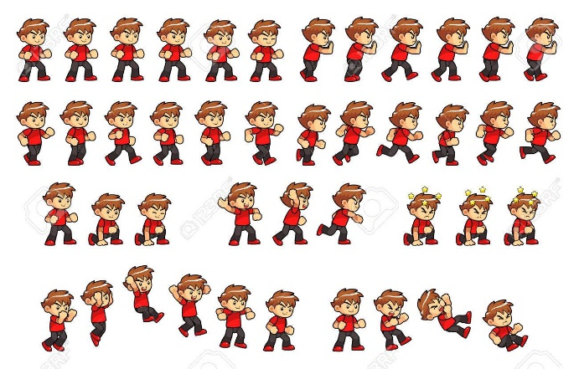

Graphically the monster should look similar to this :

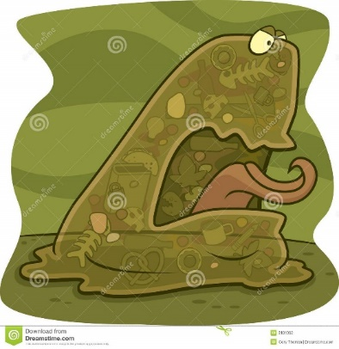

**FIRST LEVEL**

(Animation)The scene starts with the main character that is sailing in a polluted sea, there is oil in the water. Suddently the boat gets stuck because in the oil, the main character gets off the boat, he lands on a platform made out of plastic garbage. He starts running.

Background: oli spill coming from an oil tanker, it’s polluting the sea.The scena stars when the sun is rising.

Graphically, the background has to look like this picture but with the elements described from us.

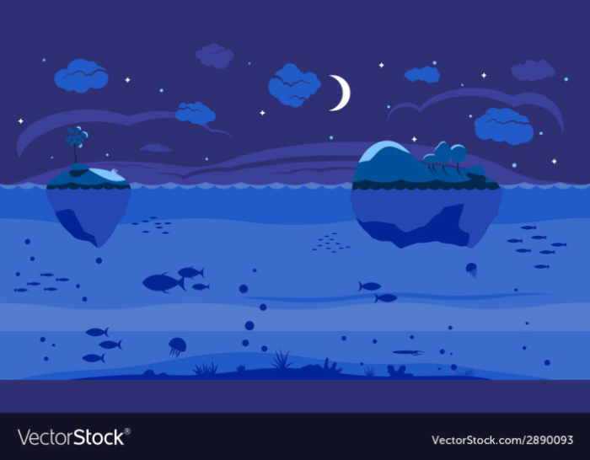

From the the start of the run there is a monster made out of oil that follow us for the whole game. During the run on the plastic platorms, if the character falls in the oil he dies. In the level there are waves made out of plastic garbage that if they hit the main character, they slow him down. There is a dolphin with oil on him, that is jumping between the platforms. The main character has to jump or slide to avoid the creature, if the dolphin hits him the main character dies. There are some obstacles made out of sharp plastic, thay can kill the main character if he touhes them. Some of the platforms sink slowly when the main character jumps on them. There are some seagulls that are flying, they can’t go straight because of the oil that is on their wings. The main character to avoid them, has to jump or slide. The last obstacles are ponds full of oil, these ponds are on the plastic platforms.

**SECOND LEVEL**

Background: glaciers that are melting slowly. Thera are also rocks in the ice, they should be under ice but now is too hot. There is only one platform made out of ice, the main character is running on top of it. During all the level there is an iced wind that can slow the main character, he has to avoid it. On top of it there are clefts (holes), that are covered and hidden by snow, if the main character steps on the snow he falls down in the cleft. Then at one point, there is a little mountain and the character goes up, while he is going up the mointain he has to avoid balls made out of snow. If they hit the main character, he dies. On the top of the mountain the main character has to jump on some platforms made out of ice, they are very tall. When the main character jumps on them, these platforms brake down and collapse.



Graphically we want a scene looking like this with our game elements.

**THIRD LEVEL**

Background : there is incinerator that makes a lot of smoke, there are hills made of plastic like a rubbish dump.

The main character has to avoid metal sharped object that he finds during the path. He runs on the ground covered by plastic. There are rats that suddently appear in the scene from the garbage , if they hit you the main character slow down. There is acid rain that you have to avoid jumping or sliding. There are plastics bags that fly and if they hit you , the main character slow down, if you hit two of them in a row the monster of oil that is following you kills you. There are tires that are on fire that appear on the scene suddently from the left, if they hit you,you die.The last element that can slow down you are little heaps that you have to jump. During the whole path of this level the main character goes up and down from little mountains of plastic.

**FOURTH LEVEL**

Background : City with smog , skyscrapers that are dirty and ruined , the scene is full of smoke. The are shapes of people using the smartphone in front of the skyscrapers.

The graphic of the level should look like this with the elements described from us.

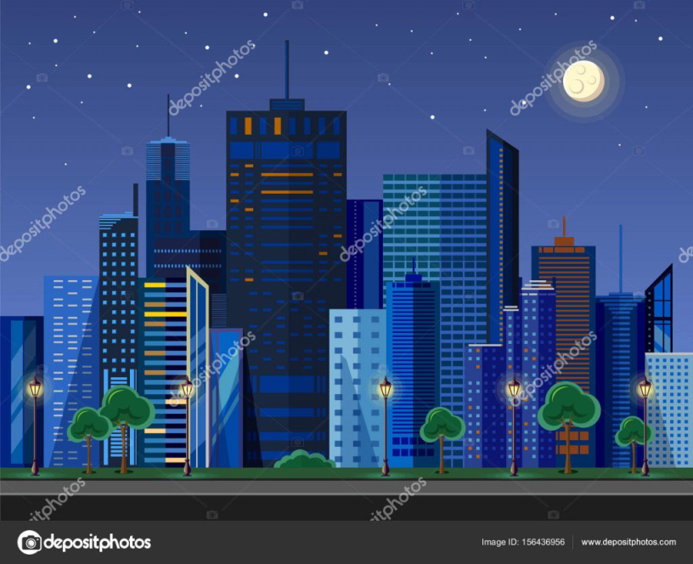

One of the main obstacles is a toxic smoke darker than the main one in the scene , it come from open manholes, if you fall in them you die. If you hit the smoke two times, you die because the monster of oil kills you.The are ruined cars with tyres full of holes that you have to jump. The are american kind looking garbage baskets that rolls and you have to jump to avoid them.The are dismissed light poles that are not straight,they are broken and curved, for that the eletric wires are not thesis and they are curved falling from you pole to another, you have to slide to avoide the tyres, if they hit you , the main character dies. The is a scene with an earthquake and the screen of the game moves a lot simulating the effects, there are part of building that fall down to the path during the earthquake and the player has to avoid them. At the end of the level there is a bridge that start breaking and falling when you run on hit, if you fall down you die (there is the toxic smoke in this scene too). In this part of the level there are not buildings in the background.

**FIFTH LEVEL**

Background : city on fire, full of flames.

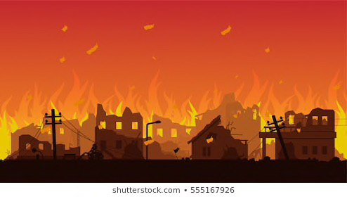

The graphic of the level should look like this with the elements described from us.

There are burning debris that rain from the sky and the character has to avoid them. During the level you have to jump on cars that are burning after that you passed them they blow up and shoot in the air a lot of debris on fire to your direction.The player has to avoid them. There is a dense back smoke that you have to avoid, if it hits you ,the character slow down. During the falling of the debris there is a kind of earthquake that moves the screen. In some point of the platform starts to breaking the asphalts and when you are near these points some flares start popping out of the ground. There are burning tyres that appear on the screen from the right. The most difficult obstacle in the level are ultraviolet light that appear in the screen in diagonal from the top and you have to jump them, after you jump them they disappear.

**SIXTH LEVEL AND FINAL LEVEL**

Background : night full of starts , burnt ground humid and dark.

This level is the easiest, there are rocks and ravines to avoid, after a little the player arrives in a scene where there is nothing and he start walking on a mountain , on the top there is a little bit of ground different from the other where the player can plant the little plant that he has in the vase, at that point start an animation and the plants start dying ,after that the plant his death the scene start dissolving and appear on the screen in white on black “it’s your choice” and after a little bit under it appear the frase in white “Convince yourself and the others to make the difference”.The game ends and you find the final card and two random card from the collection with these possibility 1) 30% common 40% rare 30% legendary 2) 50% common 40% rare 10% legendary. You can finish the game every time you want, and if it isn’t the first time you will find two cards with the possibility said before.

P.S. Every level will have a different song provided from us.

**SETTINGS**

If the player clicks on this botton we will be taken to a page that shows him a botton to set on/off the music of the game, one where there is written abouts us , one where is login with facebook.

**RANKINGS**

In this page we need that the player can see if his facebook friends have finished the game. The rankings are based on how many cards you and your friends have collected. But every type of card has a different value in the leadboard. Common 1 point / Rares 2 points / Legendary 3 points / Final card 5 points.

**SHOP**

In the shop you can buy differents things, but with money you can only buy seeds. There are four bundle to buy them :

10 seeds for 1,99 $ 25 seeds for 4,99 $

50 seeds for 9,99 $ 100 seeds for 19,99 $

With them you can buy two different things coins or vases. The graphic of the vases has to be similar to the graphic of the game’s logo. With one, two or three little plants in it (one for each bundle).

**There are three types of vases :**

- One plant in the vase : it costs 10 seeds and the player recives one card (explained in the next chapters) it can be common, rare or legendary.

- Two plants in the vase : it costs 20 seeds and the players recives two cards that can be commons, rares or legendary and 100 coins.

- Three plants in the vase : it costs 25 seeds and the player recives three cards that can be commons, rares or legendary and 200 coins.

If you find in any of these a duplicate card you already have you will recived respectivly :

Commons = 50 coins ; Rares = 100 coins ; Legendary = 150 coins ;

These are the % to find these cards in the vases

10 seeds vase )80% common 18% rare 2% legendary for each card

20 seeds vase )50% common 40% rare 10% legendary for each card

25 seeds vase )40% common 40% rare 20% legendary for each card

**There are three types of bundles for coins :**

- 1000 coins for 25 seeds - 2000 coins for 50 seeds - 4000 coins for 100 seeds

The last feature that there will be in the shop is the possibility to remove the ads for 15 seeds.

**PERSONAL PROFILE**

The personal profile there are two bottons upgrades and card collection.

**Upgrades :**

There are three types of upgrades : jacket ; trousers ; shoes. Each of them can be upgraded six times with these relative costs in coins.

1. 100 c 2) 250c 3) 500c 4) 1000c 5) 2000c 6) 4000c ;

Each time the player upgrades them the main character will gain rispectivly : velocity ; sliding ; jumps by a fact of x/100 better that before .

**Collection of cards :**

In total we want that the player can collect 31 cards. In this section he can see which one he has find in vases or during the game.

There are 14 commons , 10 rares and 6 legendary. One card can be found by each player only one time and it is given at the end of the run. It rappresent a real tree that will be planted in the reality. (explained in next chapters). In fact all of the card is a different type of tree. We use as reference for this feature the famous game Clash Royale <https://clashroyale.com/>

<https://play.google.com/store/apps/details?id=com.supercell.clashroyale&hl=en>

If you want to understand how we want our collection to work you can download it and see the card list. If the player has found a card , in the collection it is seen shining and full of colors. If he has not find that card, i twill be seen with out colors, only in different shades of grey.

The layout of the common cards has to be simpler than the one for the rare one’s and the same thing is between rares and legendary.

**How to collect the coins** : The coins are foundable every 5 seconds (for each one) in the game in a casual position, and at the end of the match you’ll see them collected in your portfolio. There is a coins-counter in the left top corner of the game during every match (like the metres counter). You can see your portfolio and you can spend the coins in upgrades in your personal profile section.

**How to get the cards :**

The game is long 5500 m , 1000 m for each level beside the last one that is 500 m.

During the game on the right top there is a total counter of the metres runned from the player and these are the metres needed to unlock the cards. When you unlock the card you have to run for the next sequence of metres to unlock another card. When you complete the last sequence the player restart from the first one.

500 m card n1 90% common 9% rare 1% legendary

1500 m card n2 85 % common 12% rare 3% legendary

3500 m card n3 80% common 16% rare 4% legendary

6500 m card n4 70% common 25% rare 5% legendary

10500 m card n5 55% common 39% rare 6% legendary

15500 m card n6 45% common 47% rare 8% legendary

**List of cards :**

latin name/english name , the latin name has to be put under the english name and will be in cursive, the english name is bigger in the bottom center of the card.

**Commons cards :**

Abies / Fir Ficus carica / Fig tree Quercus / Oak Malus domestica / Apple tree

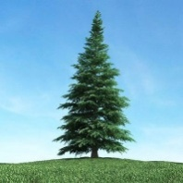 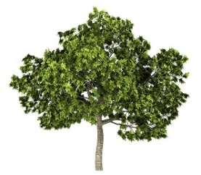 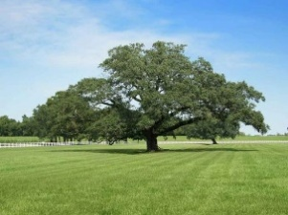 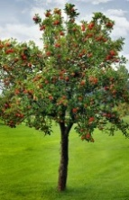

Fagus sylvatica / Beech Olea europaea / Olive Balfourianae / Bristlecone Pine

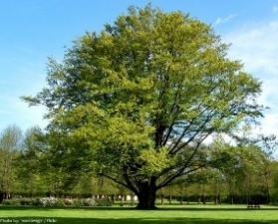 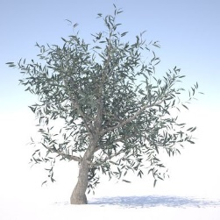 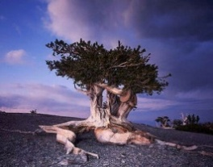

Tilia Platyphillos / Lime Acacia / Acacia 盆栽 / Bonsai

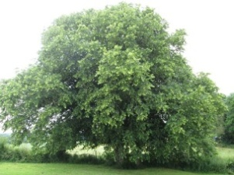 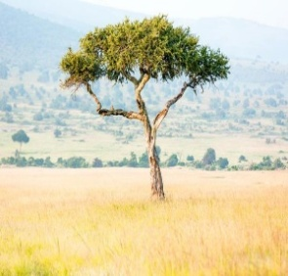 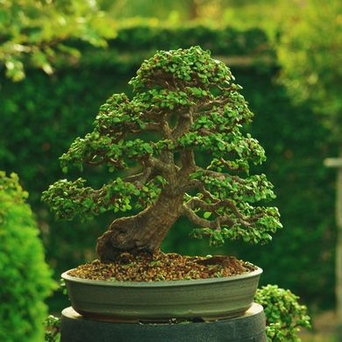

Castanea Sativa / Chestnut Citrus sinensis / Orange tree Juniperus / Juniper

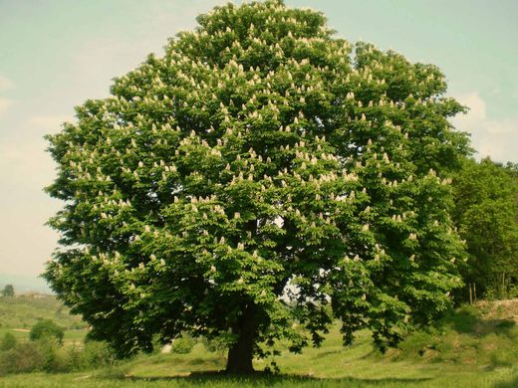 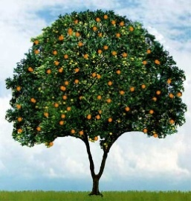 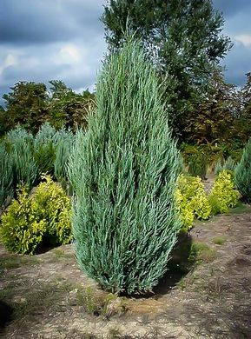

Araucaria / Araucaria

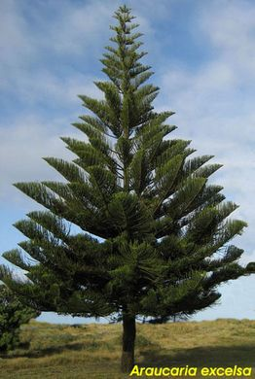

**Rares cards :**

Adansonia / Baobab Salix babilonica / Babilon willow Prunus avium / Wild cherry

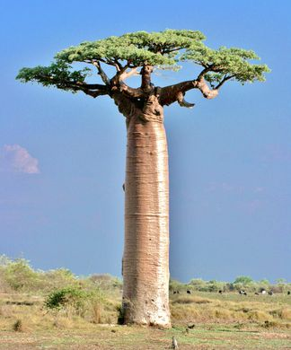 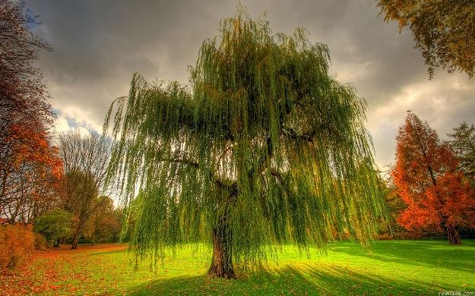 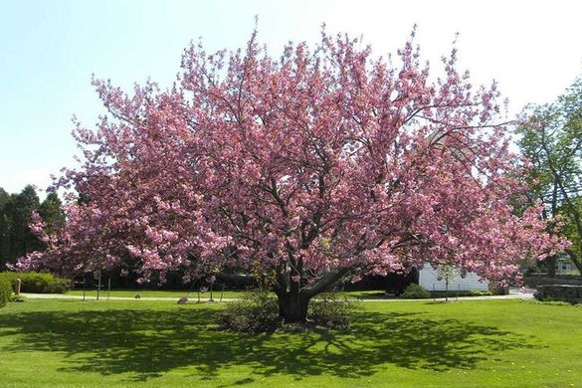

Cocus nocifera / Cocunut tree Tamarix / Tamarisk

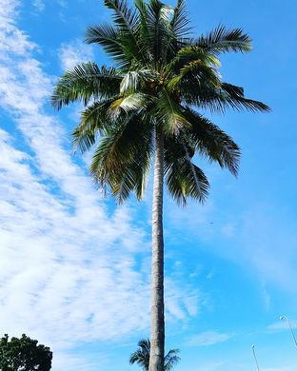 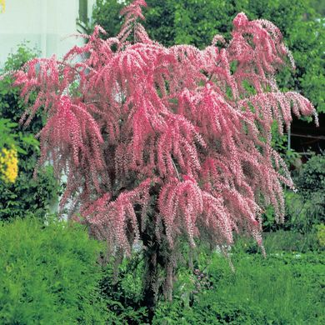

Carica papaya / Papaya Betula pendola / Silver birch Dracaena draco / Dragon tree

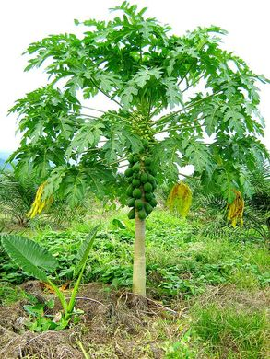 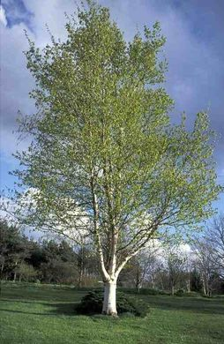 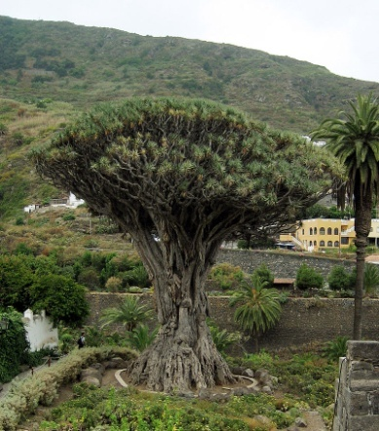

Cupressus /Cypress

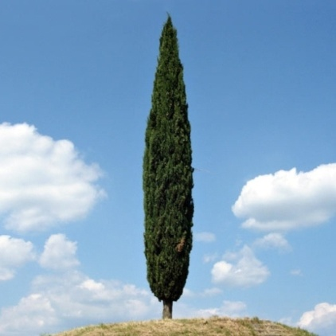

**Legendary cards :**

Prunus dulcis / Almond Acer / Maple Wisteria / Wisteria

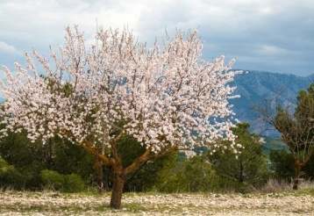 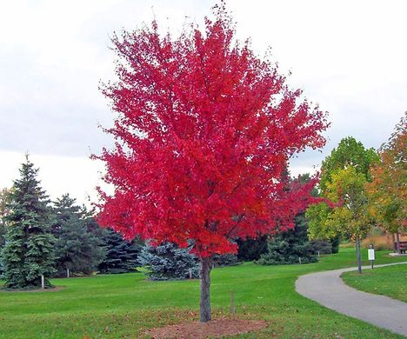 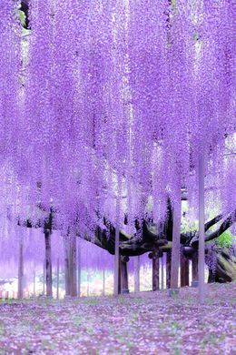

Eucalyptus deglupta / Rainbow eucalyptus Jacaranda / Jacaranda Sequoioideae / Redwoods

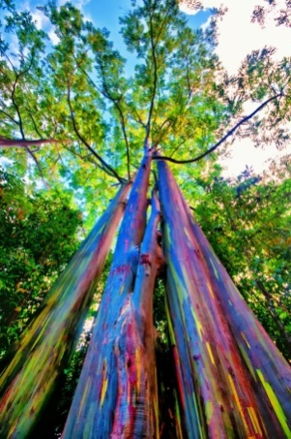 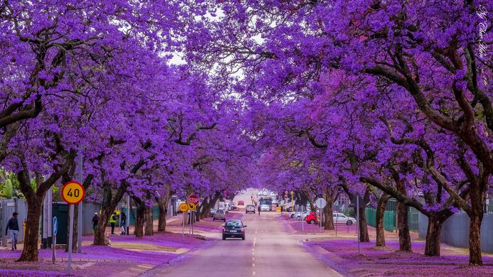 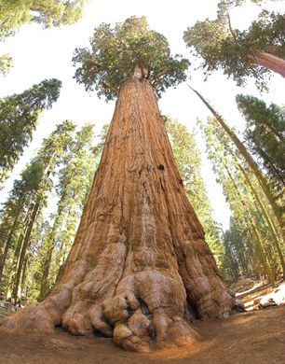

**Final card :**

Albizia gummifera / peacock flower

